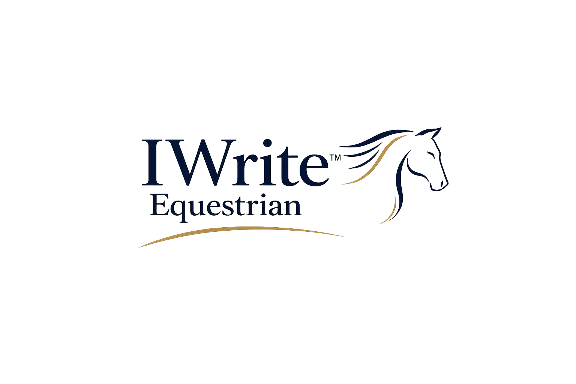
IWrite Equestrian
Compliance Roadmap
Documents, gaps and next-step support for yards and equestrian businesses
This roadmap helps a yard, coach, livery business or equestrian professional understand which IWrite Equestrian compliance documents cover which issues, how the documents fit together, and where further business-compliance support may be needed.
Need | Aim | Flow | Outcome
To make the compliance document range easier to navigate. | To help the user choose the right document, pack or tailored route. | Start with the issue, select the closest document, then identify any wider business gaps. | A clearer, more professional compliance system that supports welfare, safety, records and growth.
Important note
This roadmap is not legal, HR, financial, insurance, health-and-safety or safeguarding advice. It helps identify document routes and likely support needs. Where regulated, specialist or urgent issues arise, the business should seek appropriate professional advice or contact the relevant authority.
1. How to use this roadmap
Start with the practical issue the business is trying to solve. Is the problem about day-to-day standards, horse welfare records, site access, safeguarding, staff/freelancers, business governance, performance-yard systems or a whole-yard compliance overview? Once the issue is clear, select the narrowest useful document first, then move into a full pack or tailored support if the issue is broader, sensitive, repeated or business-wide.
A standalone document is often useful when the yard needs one clear record or template. A pack is better where the issue has several linked parts. The Complete Yard Compliance Handbook is best used as the master route map when the business wants a whole-system view.
2. First route: choose the issue
User need / issue | Best starting document or pack | Why this route helps
We need basic yard standards written down. | Standalone 01 or Compliance Pack 1 | Creates a clear written baseline for daily operation, welfare, conduct and recordkeeping.
People are unclear about access, visitors, dogs, vehicles or site rules. | Standalone 02 or Compliance Pack 1 / Pack 2 | Sets shared expectations and gives the yard a written reference point before problems escalate.
We need better horse welfare and routine records. | Standalone 03 or Compliance Pack 1 | Records practical care information so welfare is not left to memory or informal messages.
Medication, supplements or treatment instructions need control. | Standalone 04 or Compliance Pack 1 / Pack 5 | Supports consistent care and reduces risk around missed doses, product changes, withdrawal periods or competition controls.
Emergency authority is unclear. | Standalone 05 or Compliance Pack 1 | Clarifies who can call the vet, authorise urgent action and communicate under pressure.
An accident, near miss or welfare concern has happened. | Standalone 06 or Compliance Pack 1 | Creates a factual record and a clear follow-up route.
A conduct, safeguarding or behaviour concern has arisen. | Standalone 07 or Compliance Pack 2 | Helps distinguish internal conduct management from safeguarding escalation.
A problem needs actions, owners and dates. | Standalone 08 or relevant pack action-plan section | Turns a discussion into practical follow-up rather than leaving it informal.
A matter needs review, closure or lessons learned. | Standalone 09 or relevant pack closure section | Shows what changed, what remains open and whether the matter can be closed.
The yard wants a whole compliance overview. | Compliance Pack 6 - Complete Yard Compliance Handbook | Creates a master map across records, responsibilities, review dates and linked packs.
3. Standalone compliance documents and what they cover
Standalone ref | Document | Covers | Does not fully cover
SD01 | Yard Standards and Core Operating Expectations | Basic operating standards, expectations, welfare-led routines, communication, site standards and review prompts. | Detailed risk assessments, staff files, safeguarding procedure, contracts or formal policies.
SD02 | Yard Access, Visitors, Vehicles and Dogs Rules | Access times, visitors, parking, dogs, children, contractors, restricted areas and site behaviour. | Full health-and-safety policy, fire risk assessment, planning or licensing requirements.
SD03 | Horse Welfare, Health and Routine Record | Individual horse routine, health details, handling notes, welfare monitoring and practical management points. | Veterinary advice, treatment plans, insurance advice or full livery contract terms.
SD04 | Medication, Supplements and Treatment Record | Medication, supplements, topical products, treatments, instructions, timing, administration and review. | Veterinary prescription requirements, anti-doping advice or competition governing-body interpretation.
SD05 | Emergency Contacts and Veterinary Authority Record | Owner contacts, vet details, transport, emergency authority and urgent decision-making route. | Legal ownership disputes, insurance cover decisions or complex veterinary consent issues.
SD06 | Accident, Incident, Near-Miss and Welfare Concern Record | Accidents, near misses, welfare concerns, immediate action, witnesses, evidence and follow-up. | RIDDOR decisions, formal H&S investigation, legal liability or insurer-led claim handling.
SD07 | Conduct, Safeguarding and Behaviour Concern Record | Factual conduct/safeguarding concern recording, thresholds, external support routes and temporary measures. | A full safeguarding policy, external investigation, legal advice, employment disciplinary process or regulated safeguarding casework.
SD08 | Action Plan and Agreed Next Steps | Named actions, responsibilities, dates, review points and completion notes. | Full project management, HR performance process or formal contractual variation.
SD09 | Review, Learning and Closure Record | Closure notes, learning points, outcome, review status and future action. | Formal appeal, regulated complaint closure, litigation or specialist investigation report.
4. Full compliance packs and what they add
Pack | Best for | What it adds beyond standalone documents
Compliance 1 - Operational Standards and Compliance Pack | Yards needing practical day-to-day standards and working records. | Brings standards, access, welfare, medication, emergency, incident, conduct, action and closure records into one sequence.
Compliance 2 - Safeguarding, Conduct and Site Behaviour Pack | Yards with children, vulnerable adults, staff, visitors, conduct or site-behaviour concerns. | Adds safeguarding contacts, supervision rules, vulnerable adult support, safer working, restricted access and closure tools.
Compliance 3 - Business Compliance and Governance Pack | More professional yards wanting stronger business oversight. | Adds insurance/key document registers, policy review schedules, contractors, business risk, emergency business information and version control.
Compliance 4 - Staff, Freelancer and Workforce Compliance Pack | Businesses using staff, freelancers, coaches, grooms, volunteers or regular helpers. | Adds role records, induction, training, supervision, cover, concern meetings, improvement plans and offboarding.
Compliance 5 - Competition and Performance Yard Compliance Pack | Competition yards, producers, training yards and performance-focused owners. | Adds performance standards, goals, named personnel, eligibility, anti-doping/product control, travel, communication and event review records.
Compliance 6 - Complete Yard Compliance Handbook | Yards wanting a full compliance map and oversight system. | Provides the master overview across documents, named leads, review dates, risk registers, contractors, complaints, welfare, site safety and annual sign-off.
5. What may still be missing from a business-compliance perspective
The IWrite Equestrian compliance documents provide strong practical records and customer-facing structure. They do not replace specialist professional advice or regulated documents. The table below helps users understand common business-compliance areas that may sit outside the current templates or may need tailoring.
Business-compliance area | Why it may matter | Current route / where to get support
Formal legal terms, contracts and liability wording | Yards may need livery agreements, service terms, loan/share agreements, freelance terms, sale agreements, disclaimers or bespoke clauses. | Use the IWrite Equestrian Contracts section where suitable. For legal advice or high-risk wording, instruct a suitably qualified solicitor. For tailored document creation, contact IWrite Equestrian with requirements.
Employment law and HR documentation | Employee contracts, disciplinary processes, grievance procedures, working time, holiday, sickness, status, redundancy and employment rights need specialist handling. | Use the Workforce Pack for practical records. For employment law advice, use an HR specialist or employment solicitor. Tailored support may later sit through The Executive Office Company once established.
Health and safety policy and risk assessments | Yards may need written H&S policy, risk assessments, first-aid arrangements, fire procedure, manual handling, lone working, COSHH, vehicles, machinery, children and public access controls. | Use Compliance Packs 1, 2, 3 and 6 as record support. For formal H&S policy/risk assessment work, contact IWrite Equestrian with requirements or use a competent H&S adviser.
RIDDOR and accident reporting | Some workplace injuries, dangerous occurrences and work-related ill health must be reported to HSE under RIDDOR. | Use Standalone 06 for internal recordkeeping. Check HSE guidance and use the RIDDOR reporting route where required.
Data protection, privacy and retention | Safeguarding, complaints, staff, client and horse records may include personal or sensitive information requiring lawful basis, secure storage and retention decisions. | Use the compliance records as practical forms. For a privacy notice, retention schedule or data audit, contact IWrite Equestrian with requirements or use a data-protection adviser/ICO guidance.
Insurance review and claims handling | Yards need to understand public liability, employers' liability, care/custody/control, vehicles, events, contractors and exclusions. | Use Business Compliance Pack registers. Confirm cover with an insurance broker and insurer. Do not rely on IWE documents as insurance advice.
Licensing and regulatory approvals | Riding schools, animal activities, local-authority licences, planning, events, coaching programmes or commercial activities may have specific requirements. | Use packs to organise evidence. Check local authority, governing body and specialist advice requirements. Contact IWrite Equestrian for document support once requirements are known.
Finance, tax, payroll and accounts | Payroll, VAT, accounts, expenses, invoicing, self-employed status and tax treatment are outside the document templates. | Use an accountant, bookkeeper or payroll provider. The Executive Office Company may later provide operational coordination, not regulated accountancy advice.
Environmental, waste and land management | Muck heap, waste, water, chemicals, drainage, pest control, manure, environmental permits and land responsibilities may apply. | Use Business Compliance and Complete Handbook registers for oversight. Seek local authority, Environment Agency or land-management advice where needed.
Transport, trailers and vehicles | Transporting horses, business vehicle use, trailer checks, operator requirements, insurance and driver competence may need separate controls. | Use the compliance calendar and risk registers for reminders. Seek transport, insurer or specialist advice for obligations.
Accreditation and governing-body standards | BHS Approved Centre, British Equestrian, Pony Club, riding club, discipline-specific or FEI-related settings may have extra standards. | Use relevant IWE packs to organise evidence. Check the current governing-body rules and ask IWrite Equestrian for tailored document support.
6. Tailored support route
At this stage, where a customer needs a document, system, pack or business-compliance document that is not yet available as a standard product, they should contact IWrite Equestrian with their requirements. The request should explain the type of business, the issue, what documents already exist, what feels missing, whether the matter is urgent or sensitive, and whether the customer needs a standalone document, a pack, a review or a tailored system.
Once the wider platforms are established, customers may also be directed to IWrite for writing-led documentation support and to The Executive Office Company for wider business, governance, executive-support and operational documentation routes. These routes should be positioned as practical document and management-support services, not as a substitute for regulated legal, HR, safeguarding, accountancy, insurance or health-and-safety advice.
Support need | Information the customer should provide | Likely route
A document is missing from the shop | What the document is for, who will use it, and what problem it needs to solve. | Contact IWrite Equestrian for tailored creation.
Existing paperwork feels weak or inconsistent | Upload or describe current documents, concerns and business setting. | IWrite Equestrian document review or tailored refresh.
The issue crosses contracts, complaints and compliance | Explain the relationship, what has happened, what is already recorded and what outcome is needed. | Tailored IWrite Equestrian support; specialist advice if legal, safeguarding or HR issues are live.
The business wants a professional whole-yard system | Business type, services, staff/freelancers, clients, horses, risks and current documents. | Complete Yard Compliance Handbook plus tailored document mapping.
The need is broader business governance or operational support | Business structure, meetings, policies, delegated responsibilities, workflow and management pain points. | Future route: The Executive Office Company once established, with specialist advisers where regulated.
7. Practical customer checklist
Question | Yes / no / notes
Do we have clear written yard standards?
Do we have access, visitor, vehicle, dog and children rules?
Do we have one current record for each horse where needed?
Do we have medication, treatment and emergency authority records?
Do we know how to record accidents, near misses, welfare concerns and conduct issues?
Do we know when safeguarding must go outside the yard?
Do we have staff/freelancer records, induction and training evidence?
Do we have business registers for insurance, policies, contractors and review dates?
Do we know what is missing and whether it needs tailored support or specialist advice?
Tailored support
IWrite Equestrian can expand, tailor, complete, review or create documents specifically for your establishment. Please contact support@iwriteequestrian.org.uk with your requirements.

